Insured Assurance Project 1

Student name: Sushant P. Bhagat

PG DO: DevOps Foundations: Version Control and CI/CD with Jenkins

To create a GitHub Actions CI/CD pipeline workflow for invoking the deployment of a Java application
as a Jenkins job using Tomcat Apache
Insured Assurance, a leading global insurance provider based in the US, offers a range of products
including home, health, car, and life insurance. The company is transitioning to a DevOps architecture
and aims to automate code builds and deployments across various environments. To meet this need,
it has adopted GitHub Actions for code checkout, building, and testing automation and Jenkins for
continuous deployment. As a DevOps engineer at Insured Assurance, you are tasked with
implementing a CI/CD pipeline using GitHub Actions and Jenkins.
The following tasks outline the process of implementing CI/CD using GitHub Actions and Jenkins:

1. Create a code repository on GitHub
2. Create a GitHub Actions pipeline to perform continuous integration
3. Configure Tomcat Apache for automated code deployment
4. Integrate the GitHub Actions pipeline to invoke the Jenkins pipeline
5. Invoke pipeline to validate automated deployment

Write-up:
At Insured Assurance, I was tasked with setting up a CI/CD pipeline to automate the deployment of a
Java application as part of the company’s DevOps transition.
I created a GitHub repository for the Java application's source code and set up a GitHub Actions
workflow to handle continuous integration (CI). This workflow automated code checkout, build
processes using GitHub. To link GitHub with Jenkins, I configured a webhook to trigger a
Jenkins freestyle job upon code pushes to the repository.
The GitHub Action was responsible for continuous deployment (CD), deploying the built WAR file to the
Tomcat server. This setup ensured that Jenkins could download the artifact and initiate the deployment
process on Tomcat automatically. By integrating infrastructure with GitHub Actions and Jenkins,
I successfully automated the deployment pipeline, overcoming the constraints of my initial lab
environment and achieving a streamlined, efficient DevOps workflow.
Pre-requisites: GitHub Account
Steps

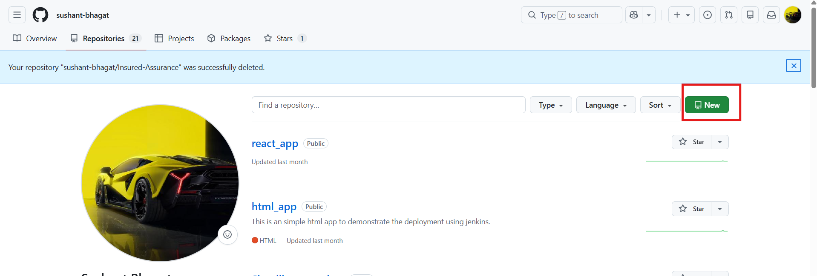
- Create a GitHub repo of type public with README file on it.

- Click on Actions Click on setup a workflow yourself.
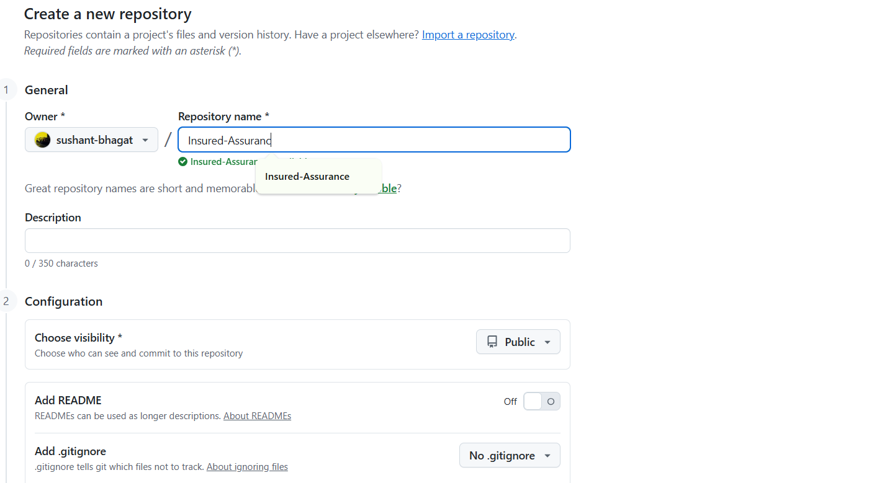
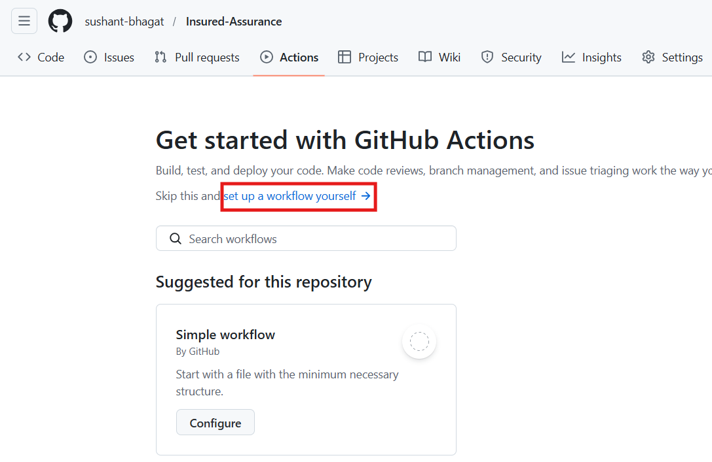
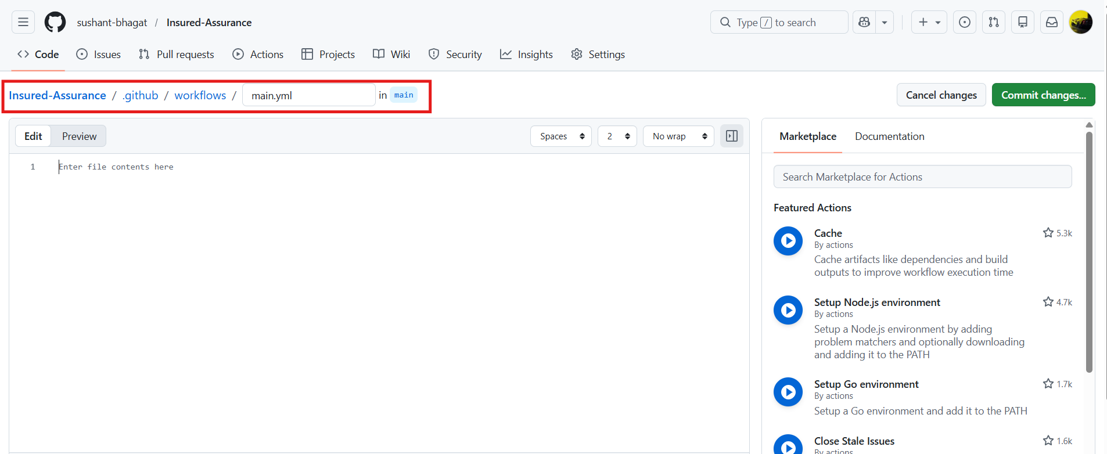

- You will see a main.yml → add the below code
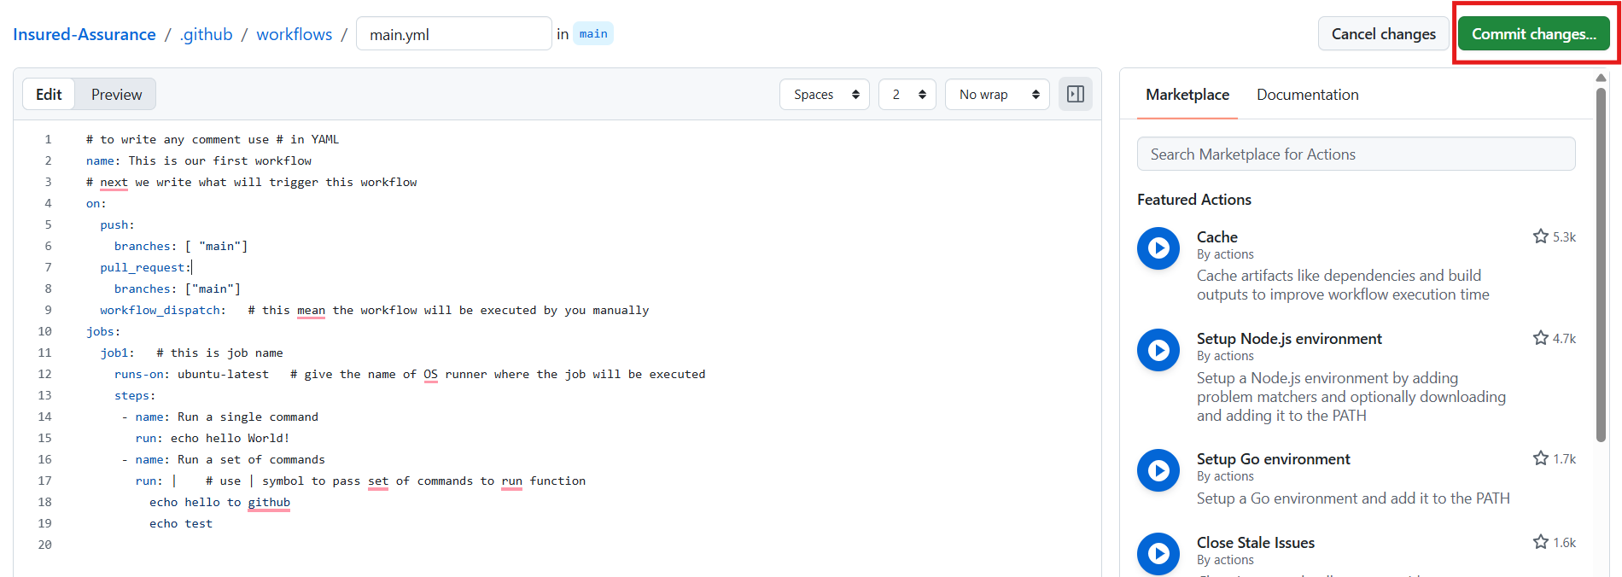

- Commit the file.

Click on Actions again →you will see your workflow→ click on workflow→ click on your job and you will see the output.

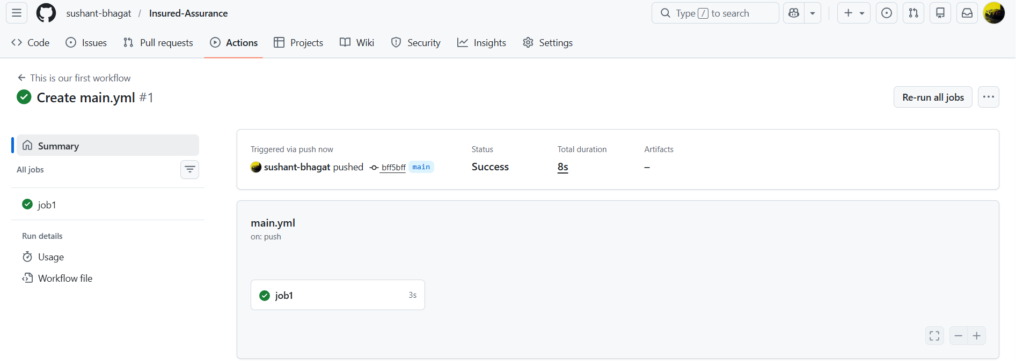

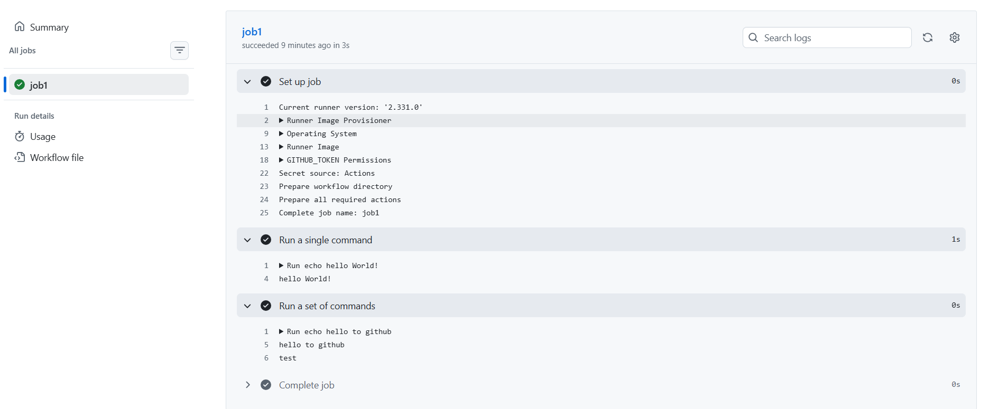
- On the GitHub repository create secret variables that we will use in the CICD GitHub Action workflow
- For this go to Settings tab of repository > go to secrets and variables > click on to Actions > Secrets Tab > Repository secrets
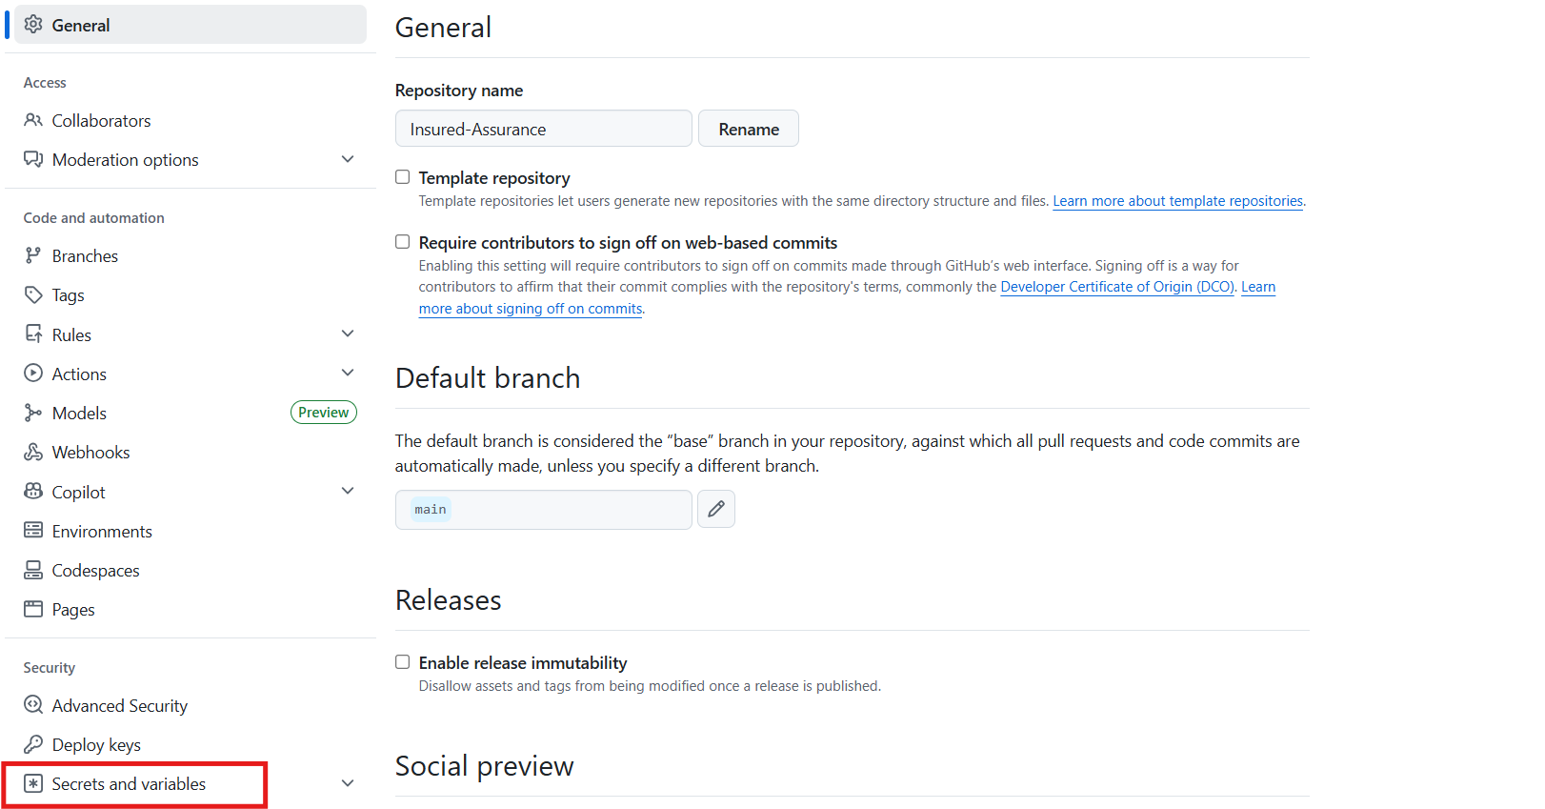
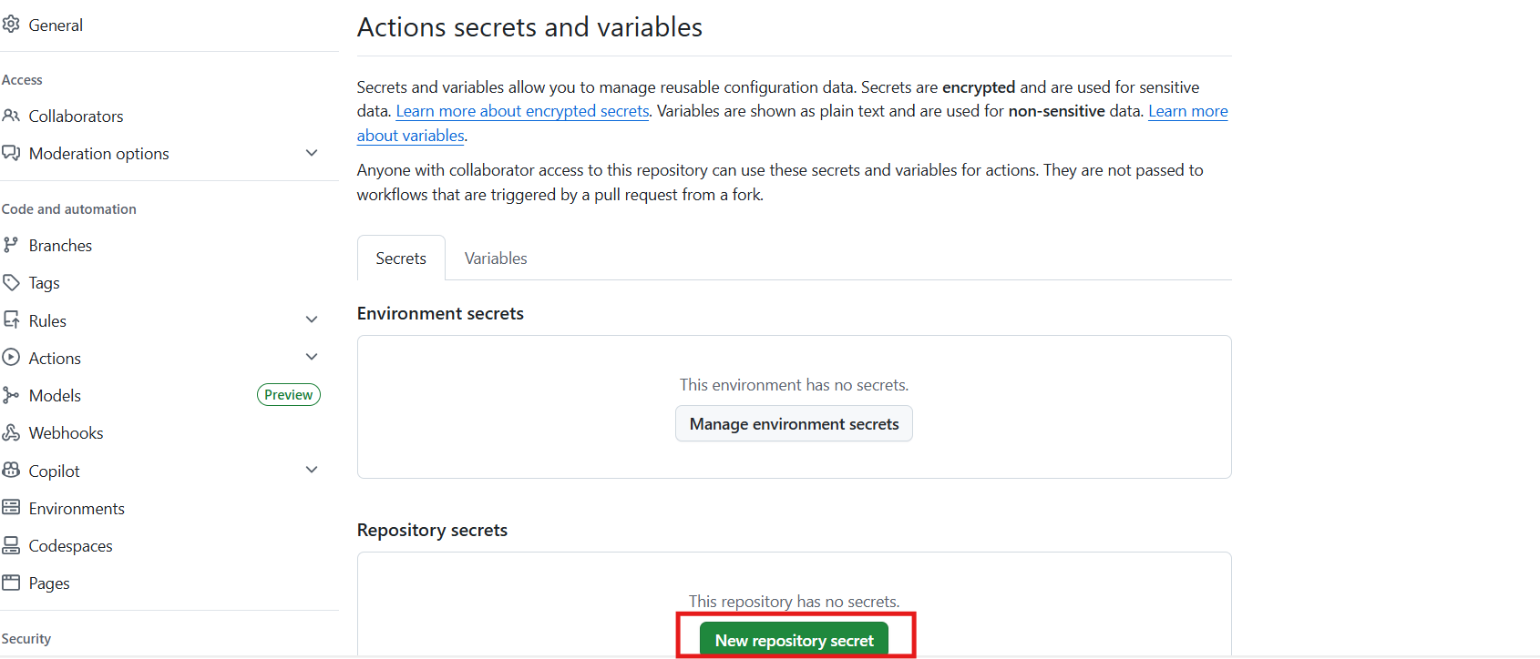
- click on new repository secret.
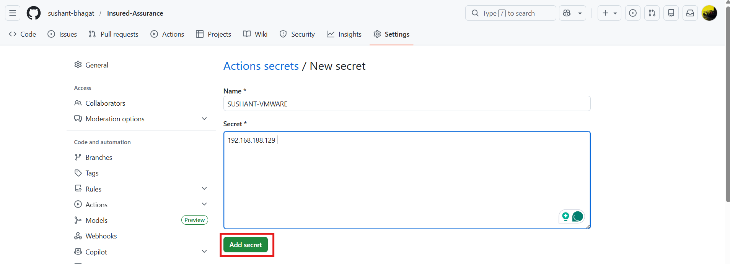
- Install Java
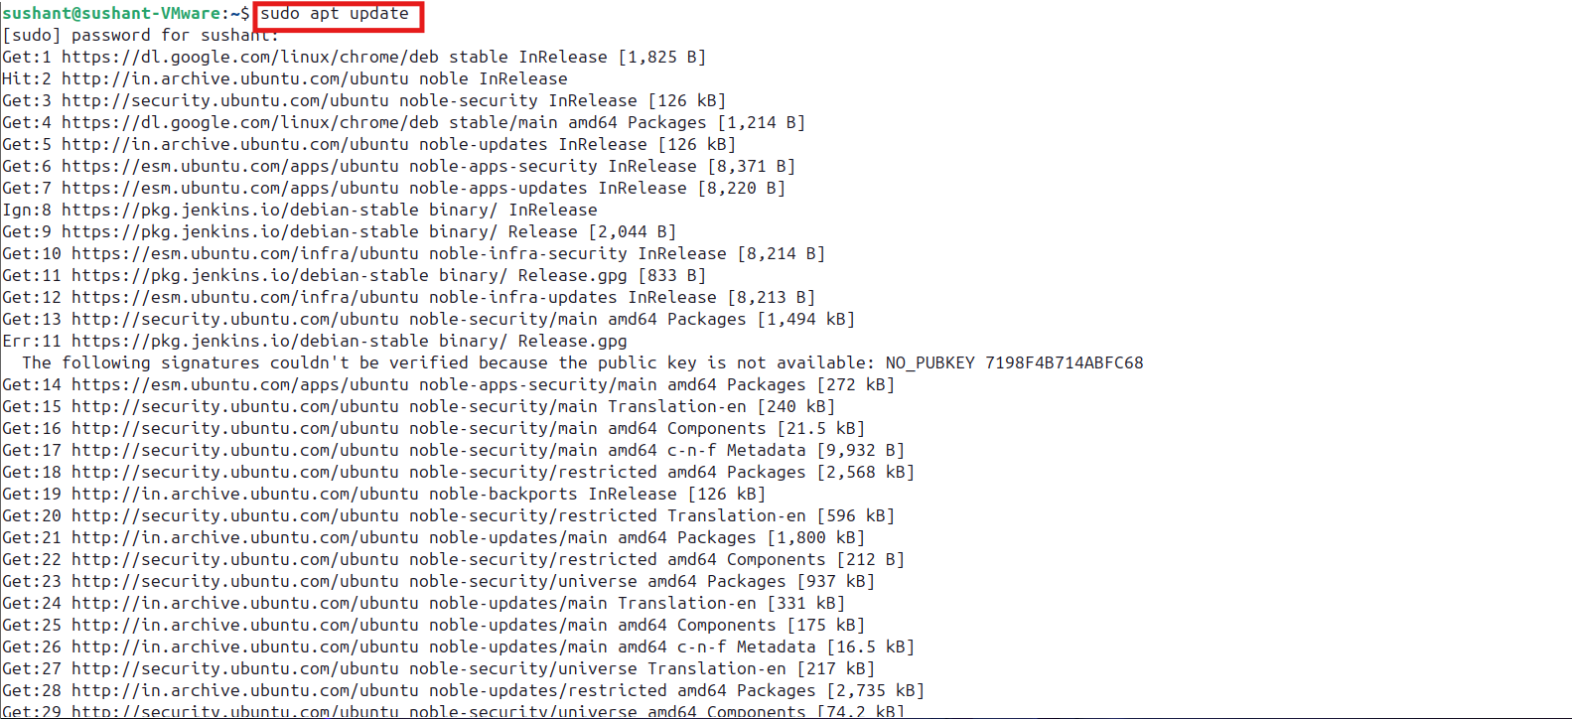
- Check Java Version
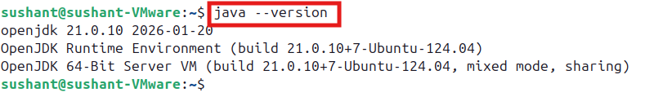
- Install Tomcat
$ sudo apt update
$ sudo apt upgrade -y
$ java -version
$ sudo useradd -m -U -d /opt/tomcat -s /bin/false tomcat
$ cd /tmp
wget https://downloads.apache.org/tomcat/tomcat-10/v10.1.20/bin/apache-tomcat-10.1.20.tar.gz
$ sudo mkdir /opt/tomcat
sudo tar -xzf apache-tomcat-10.1.20.tar.gz -C /opt/tomcat --strip-components=1
- Give permissions:
$ sudo chown -R tomcat:tomcat /opt/tomcat
sudo chmod -R u+x /opt/tomcat/bin
- Create Tomcat Service File
$ sudo nano /etc/systemd/system/tomcat.service
Paste this:
[Unit]
Description=Apache Tomcat Web Application Container
After=network.target
[Service]
Type=forking
User=tomcat
Group=tomcat
Environment="JAVA_HOME=/usr/lib/jvm/java-11-openjdk-amd64"
Environment="CATALINA_PID=/opt/tomcat/temp/tomcat.pid"
Environment="CATALINA_HOME=/opt/tomcat"
Environment="CATALINA_BASE=/opt/tomcat"
Environment="CATALINA_OPTS=-Xms512M -Xmx1024M -server -XX:+UseParallelGC"
Environment="JAVA_OPTS=-Djava.awt.headless=true -Djava.security.egd=file:/dev/./urandom"
ExecStart=/opt/tomcat/bin/startup.sh
ExecStop=/opt/tomcat/bin/shutdown.sh

Restart=on-failure
[Install]
WantedBy=multi-user.target

Save and Exit
- Reload and Start Tomcat
$ sudo systemctl daemon-reload
$ sudo systemctl start tomcat
$ sudo systemctl enable tomcat
- Check status:
$ systemctl status tomcat
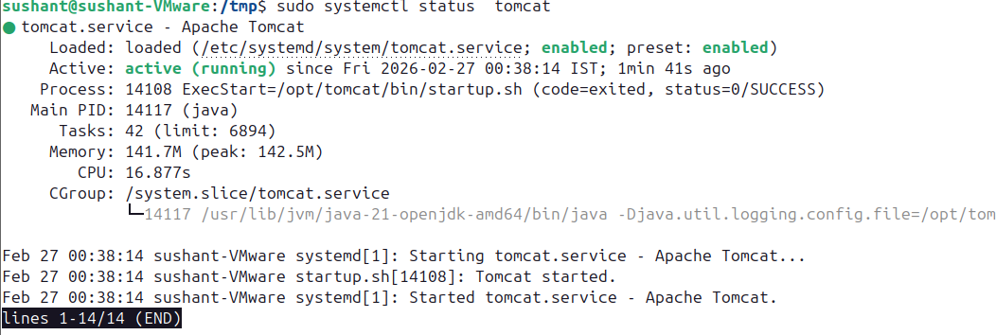

Add the below YAML:
# deploy
name: CICD using maven and SL lab
on:
push:
branches: ["main"]
workflow_dispatch:
jobs:
buildandDeploy:
runs-on: ubuntu-latest
steps:
- name: Clone the Repo
uses: actions/checkout@v4
- name: Setup JDK 21 and maven
uses: actions/setup-java@v4
with:
distribution: 'temurin'
java-version: '21'
cache: 'maven'
- name: Build with Maven
run: mvn -B package --file pom.xml
- name: connect to Lab and deploy code on tomcat
uses: cross-the-world/ssh-scp-ssh-pipelines@latest
with:
host: '10.232.112.164'
user: 'Sushant'
pass: 'Lancelot'
port: 3389
connect_timeout: 10s
first_ssh: |
sudo chmod 777 /var/lib /tomcat/webapps
scp: |
'./target/*war' => /var/lib/tomcat/webapps
last_ssh: |
sudo systemctl restart tomcat.service
Save the file
Check the file on - /var/lib/tomcat/webapps
ON the new LAB the task will be
- name: connect to Lab and deploy code on tomcat9
uses: cross-the-world/ssh-scp-ssh-pipelines@latest
with:
host: ‘10.232.112.164’
user: 'Sushant'
pass: 'Lancelot'
port: 3389
connect_timeout: 10s
first_ssh: |
sudo chmod 777 /var/lib/tomcat/webapps
scp: |
'./target/*war' => /var/lib/tomcat/webapps
last_ssh: |
sudo systemctl restart tomcat.service
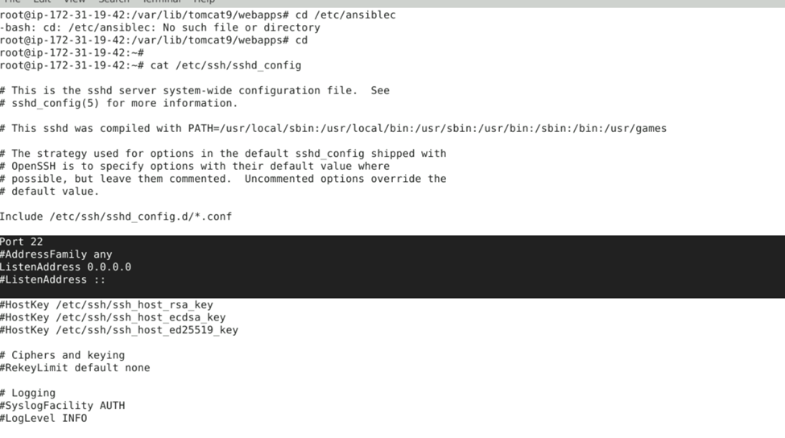
# systemctl restart sshd
Establish SSH key pair in linux system to have SSH connectivity with localhost using the following commands:
$ ssh-keygen -t rsa (Press Enter when asked for File and Paraphrase details)

$ cat .ssh/id_rsa.pub >> .ssh/authorized_keys

A new task to trigger Jenkins Job from GitHub Actions:
- name: connect to Lab and trigger Jenkins job
uses: cross-the-world/ssh-scp-ssh-pipelines@latest
with:
host: 10.232.112.164
user: 'Sushant'
pass: 'Lancelot'
port: 3389
connect_timeout: 10s
first_ssh: |
sudo curl -I -u admin:119c9af52262c4c894823a4b07f943c1f8 http://10.232.112.164:8081/job/Job1/build?token=token1
The output will look like this:
